# TED – [怎样才能获得幸福？](https://open.163.com/movie/2016/1/B/T/MBAM75U2S_MBB7LQSBT.html)

**介绍：**

是什么让我们的人生过得健康幸福呢？如果你觉得是名望，金钱，那么你和很多人一样——但精神科医师罗伯特·沃尔丁格并不这么认为。沃尔丁格是一项关于成年人发展的研究项目的负责人，该研究已经进行了75年之久。沃尔丁格史无前例地揭示了真正的幸福背后的秘密。在这次演讲中，他分享了该项研究的三个重要结论，这些结论就像那些古老而又实用的知识一样，告诉我们该如何过得幸福长寿。

1.Hindsight is 20/20 事后诸葛亮

详细解释：[Hindsight is 20/20](http://www.phrasemix.com/phrases/hindsight-is-20-20)

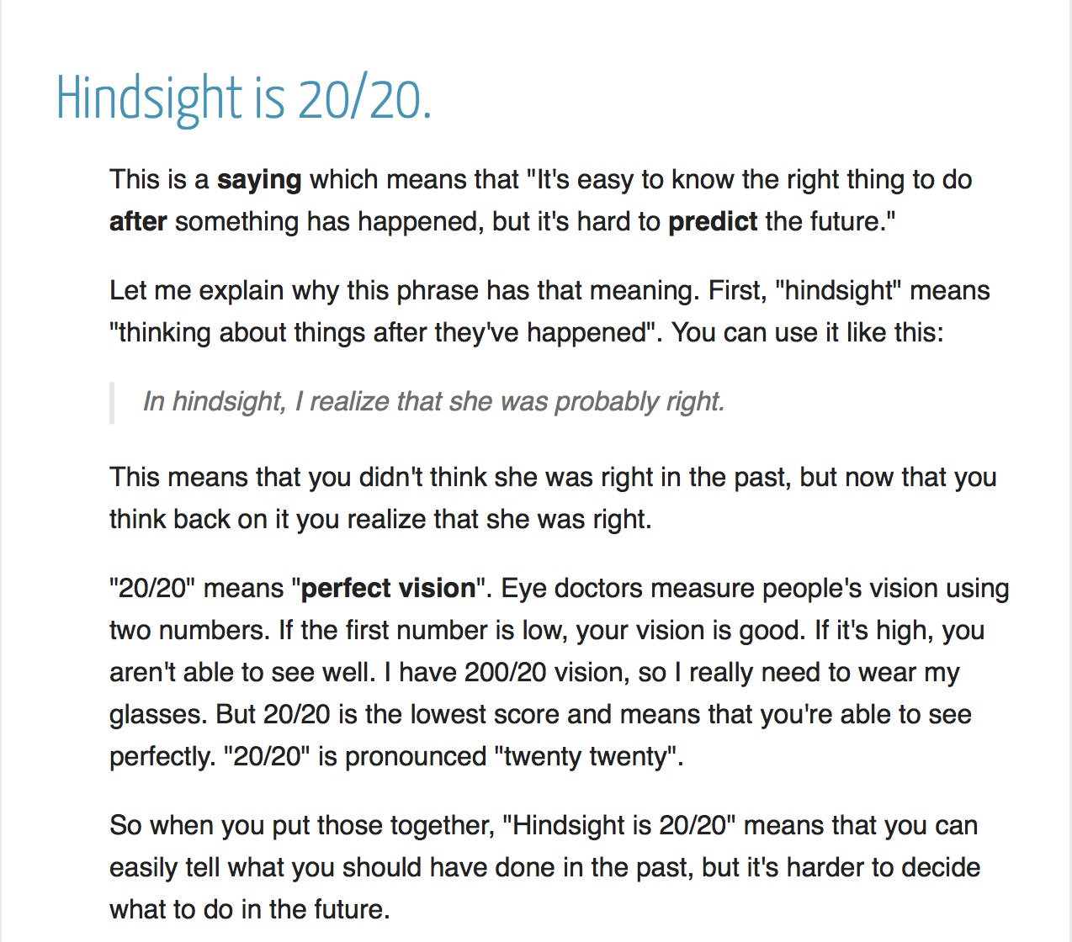

2. entire 完全的，全体的，整体的

whole 完整的，纯粹的， n. 整体，全部 强调完整性

total 全部的，完全的 / totally 一种总共的意思

complete 完整的，完全的，彻底的，v.完成

3. exceed 超过

exceeding 超越的，非常的

exceedingly 非常，极端地

extremely 非常，极其

4. toxic 有毒的

tox 毒药

5. isolate 使隔离，使孤立，隔离的，孤立的。

Alone 独自的，单独的 / lonely 寂寞的，偏僻的

6. magnify 放大，赞美，夸大 – 夸大效果或者一些情感

amplify 放大，扩大 – 一般指声音等信号放大

enlarge 放大 – 指 体积放大

7. count on 指望，依靠 / rely on /depend on

count for 解释，占比

8. toll n.通行费，代价，钟声，伤亡人数。

v. 征收，敲钟，征税

toll on 对...的严重影响

take a toll on sth 对...产生影响(不好的)

#### toll/təʊl/**CET4 TEM4**

#### **(tolling,tolled,tolls)**

1. V-T/V-I When a bell tolls or when someone tolls it, it rings slowly and repeatedly, often as a sign that someone has died. 敲 (常指丧钟); (常指丧钟) 鸣响

例：

Church bells tolled and black flags fluttered.

教堂丧钟敲响了，黑旗飘动着。

1. N-COUNT A toll is a sum of money that you have to pay in order to use a particular bridge or road. (桥梁或道路的) 通行费

例：

You can pay a toll to drive on Pike's Peak Highway or relax and take the Pike's Peak Cog Railway.

你可以付通行费开车上派克斯峰公路，或者放松一下，乘坐派克斯峰齿轨式火车。

1. N-COUNT A toll road or toll bridge is a road or bridge that you have to pay to use. (道路或桥梁) 收费

例：

Most people who drive the toll roads don't use them every day.

大部分开车上收费公路的人不是每天都走公路。

1. N-COUNT A toll is a total number of deaths, accidents, or disasters that occur in a particular period of time. (死亡、事故或灾难的) 总数

例：

There are fears that the casualty toll may be higher.

人们担心伤亡人数可能会更多。

1. → see also death toll
2. PHRASE If you say that something takes its toll or takes a heavy toll, you mean that it has a bad effect or causes a lot of suffering. 造成坏影响 (或痛苦)

例：

Winter takes its toll on your health.

冬季影响你的健康。

The good life is built with good relationships.

The lessons aren’t about wealth or fame or working harder and harder. The clearest message that we get from this 75-years study is this: Good relationships keep us happier and healthier. Period.

1. The social connections are really good for us and loneliness kills.
2. It’s not just the number of friends you have, and it’s not whether or not you’re in a committed relationship, but it’s the quality of your close relationships that matters.
3. Good relationships don’t just protect our bodies, they protect our brains.

Good, close relationships are good for our health and well-being, this is wisdom that’s as old as the hills. Why is this so hard to get and so easy to ignore?

Relationships are messy and they’re complicated and the hard work of tending to family are friends, it’s not sexy or glamorous. It’s also life-long. It never ends.

I’d like to close with a quote from Mark Twain.

“More than a century ago, he was looking back on his life, and he wrote this: There isn’t time, so brief is life, for bickerings, apologies, heartburnings, callings to account. There is only time for loving.”